AI ASSISTANT LAB
ASSIGNMENT – 2.4
NAME: P.BHARGAVI
HALL: 2303A52391
BATCH: 44
TASK 1: Book Class Generation
Prompt:“Generate a Python class named Book with attributes title and author, and include a method summary() that returns a brief description of the book.”

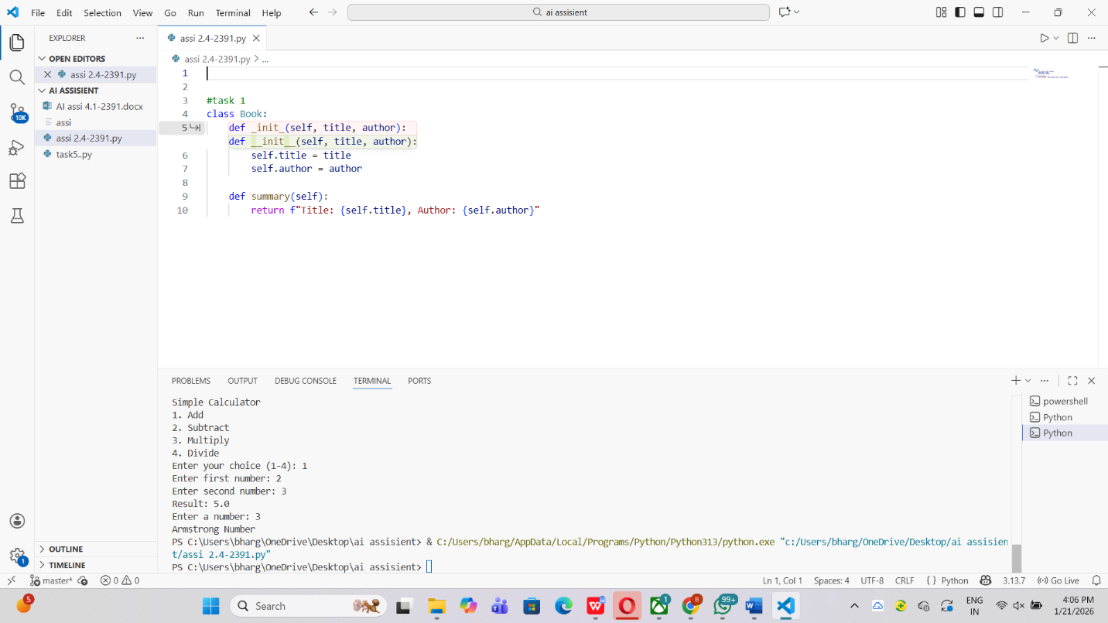

Observation :
The generated code is well-structured and follows standard Python class conventions. It uses clear attribute names and properly initializes them using the constructor. The summary() method is concise and returns formatted output, making the class easy to understand and use. Overall, the code is clean, readable, and suitable for a basic library management system.

Task 2: Sorting Dictionaries with AI
Prompt:“Generate Python code to sort a list of user dictionaries based on the age key.”

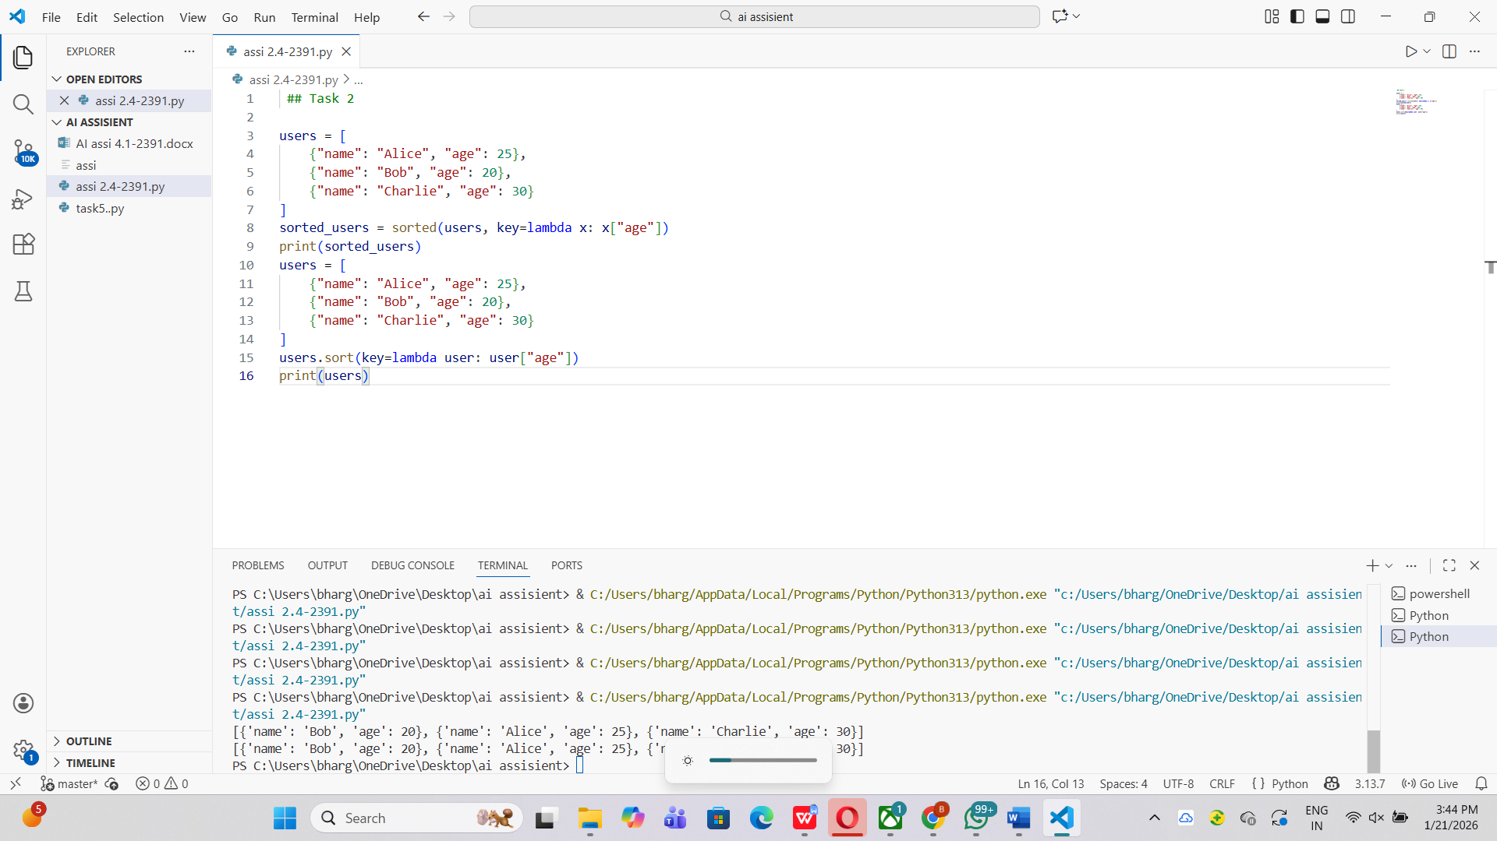

Observation :
The code efficiently sorts a list of dictionaries using Python’s built-in sorted() function with a lambda expression as the key. It is easy to read, beginner-friendly, and does not modify the original list, which improves safety and clarity. The time complexity is O(n log n), making it suitable for handling multiple user records with good performance.

Task 3: Calculator Using Functions
Prompt:“Generate a simple calculator in Python using functions for basic arithmetic operations and explain its working.”
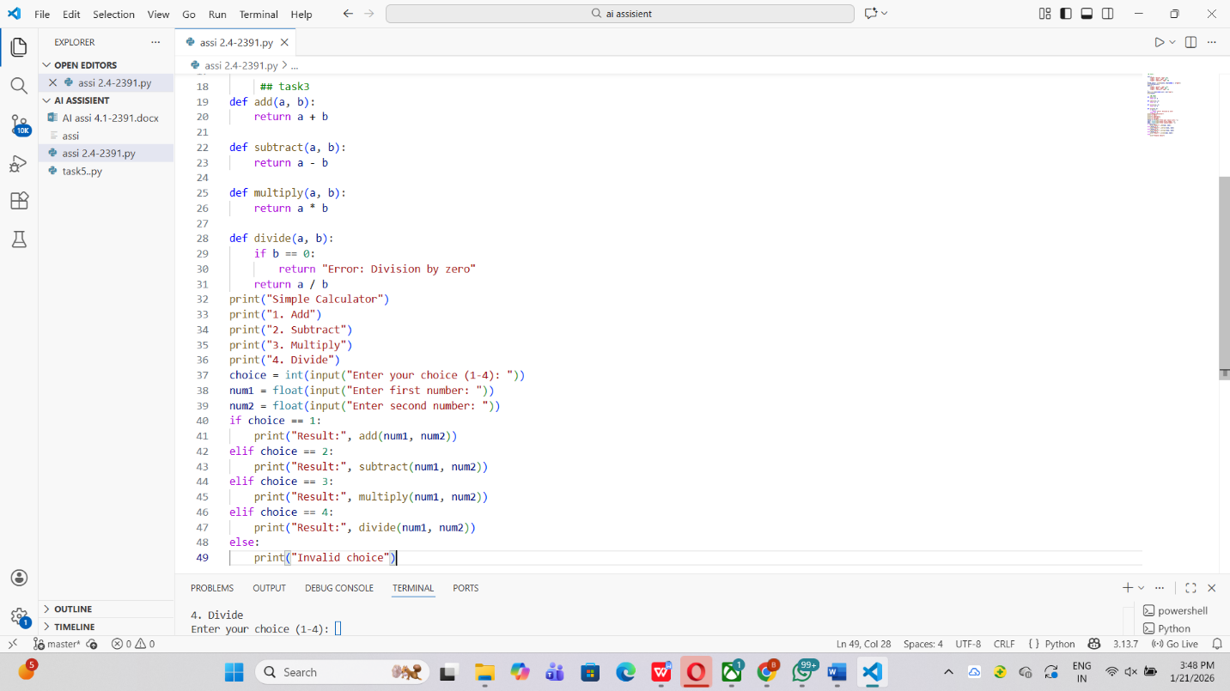
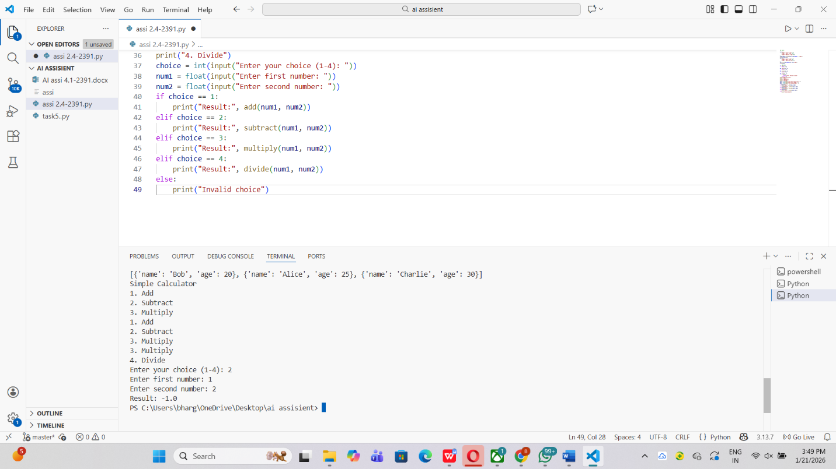

Observation :
The calculator code is well-organized and uses separate functions for each arithmetic operation, which improves readability and reusability. Error handling is included in the division function to avoid division by zero, making the program more robust. The modular design allows easy extension of the calculator by adding more operations, and the code is simple enough for beginners to understand and maintain.

Task 4: Armstrong Number Optimization
Prompt:“Generate an optimized Python program to check whether a number is an Armstrong number.”
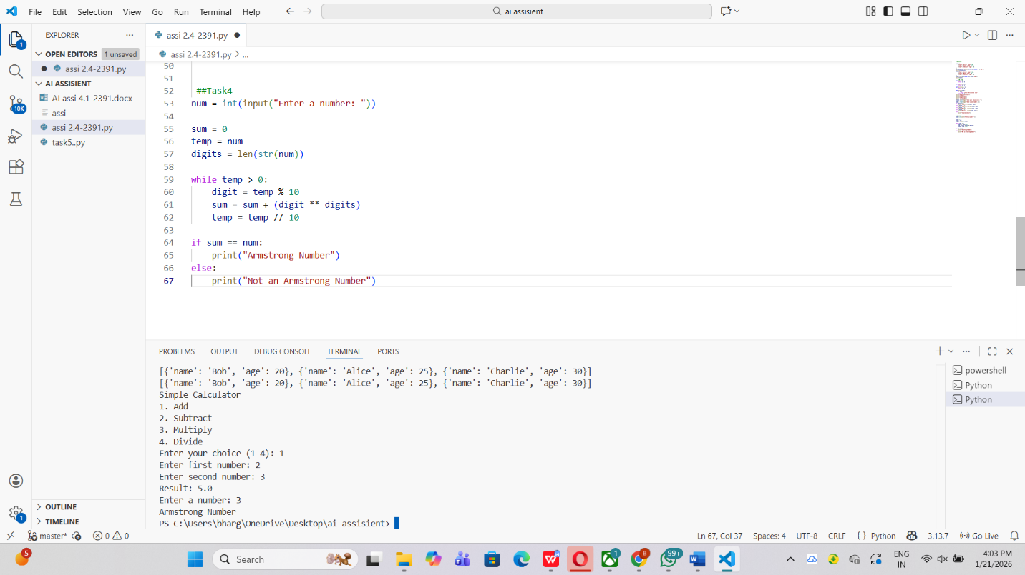

Observation :
The optimized Armstrong number program is concise, efficient, and works for numbers of any length. By converting the number to a string, digit extraction becomes simpler and avoids repeated arithmetic operations. The use of a generator expression improves readability and reduces unnecessary variables, making the code easier to understand, maintain, and extend compared to the basic approach.

